AI CONTENT PLANNER
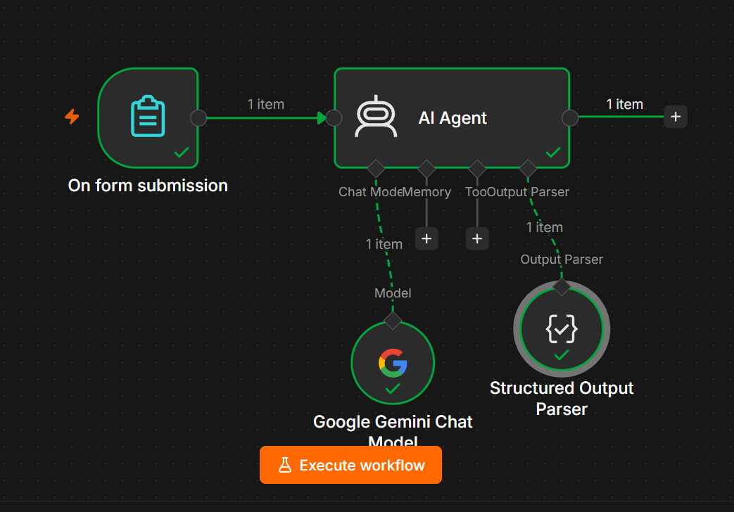
For your medium-level AI Agent practice, build the AI Content Planner using the same structure as your AI Keyword Generator.
You do NOT need a Vector Store. ✅
On Form Submission
↓
AI Agent
↙ ↘
Gemini Output Parser

1. Project Objective
The AI Content Planner takes a topic/business description and automatically creates a structured content plan.
It can generate:
- Content topics
- Content pillars
- Content titles
- Content types
- Target keywords
- Target audience
- Search intent
- Content goals
- Publishing schedule
- Content ideas
- Call-to-action suggestions
Example
Input:
Business:
Digital Marketing Agency

Target Audience:
Small business owners

Main Topic:
Digital Marketing
AI can generate:
Week 1 → What Is Digital Marketing?
Week 2 → SEO for Small Businesses
Week 3 → Social Media Marketing Strategies
Week 4 → Content Marketing Guide

2. Nodes Required
Add these nodes:
Main workflow
- On Form Submission
- AI Agent
AI Agent sub-nodes
- Google Gemini Chat Model
- Structured Output Parser
You DON'T need:
❌ Vector Store
❌ Data Loader
❌ Text Splitter
❌ Embeddings

3. Step 1 — On Form Submission
Add:
On Form Submission
Create these fields.

Field 1 — Business/Brand Name
Type: Text
Business Name
Example:
ABC Digital Marketing

Field 2 — Main Topic
Type: Text
Main Topic
Example:
Digital Marketing

Field 3 — Target Audience
Type: Text
Target Audience
Example:
Small business owners

Field 4 — Content Goal
Type: Text
Content Goal
Example:
Generate leads and increase website traffic

Field 5 — Platforms
Type: Text
Platforms
Example:
Blog, Instagram, LinkedIn

Field 6 — Content Frequency
Type: Number
Posts Per Week
Example:
3

Field 7 — Additional Information
Type: Text Area
Additional Information
Example:
We provide SEO, social media marketing and content marketing
services for small businesses.

4. Example Form
Your form will look like:
Business Name:
ABC Digital Marketing

Main Topic:
Digital Marketing

Target Audience:
Small business owners

Content Goal:
Generate leads and increase website traffic

Platforms:
Blog, Instagram, LinkedIn

Posts Per Week:
3

Additional Information:
We provide SEO, social media marketing and content marketing
services for small businesses.

5. Step 2 — AI Agent
Connect:
On Form Submission
↓
AI Agent
Use the normal workflow connection.

6. AI Agent Prompt
Set:
Prompt (User Message)
→ Define below
Use:
Create a content plan based on the following information.

Business Name:
{{ $json['Business Name'] }}

Main Topic:
{{ $json['Main Topic'] }}

Target Audience:
{{ $json['Target Audience'] }}

Content Goal:
{{ $json['Content Goal'] }}

Platforms:
{{ $json['Platforms'] }}

Posts Per Week:
{{ $json['Posts Per Week'] }}

Additional Information:
{{ $json['Additional Information'] }}

Create a structured content plan.

Generate:

1. Content strategy summary
2. Content pillars
3. Content ideas
4. Content titles
5. Content types
6. Target keywords
7. Search intent
8. Content goals
9. Suggested publishing schedule
10. Call-to-action suggestions

7. System Message
Use:
You are an AI Content Planning Specialist.

Your job is to create practical and organized content plans
based on the business, audience, topic, goals and platforms
provided by the user.

IMPORTANT RULES:

1. Create content ideas relevant to the main topic.
2. Consider the target audience.
3. Align content with the stated business goal.
4. Consider the selected platforms.
5. Use different content types where appropriate.
6. Avoid duplicate content ideas.
7. Create clear and engaging titles.
8. Suggest relevant keywords.
9. Identify appropriate search intent for content topics.
10. Create a realistic publishing schedule.
11. Do not invent business facts.
12. Do not claim actual search volume or keyword difficulty
unless real SEO data is provided.
13. Make the plan practical and easy to execute.
14. Return the result using the required structured output format.

8. Step 3 — Google Gemini Chat Model
Add:
Google Gemini Chat Model
Connect it to the AI Agent's:
Chat Model input.
Google Gemini Chat Model
↓
AI Agent
Do not use the normal workflow connection for Gemini.

9. Step 4 — Structured Output Parser
Add:
Structured Output Parser
Connect it to the AI Agent's:
Output Parser.
AI Agent
↓
Output Parser
↓
Structured Output Parser

10. JSON Output Format
Select:
Generate from JSON Example
Use:
{
"business_name": "ABC Digital Marketing",
"strategy_summary": "Create educational and conversion-focused content to increase website traffic and generate leads from small business owners.",
"content_pillars": [
"SEO",
"Social Media Marketing",
"Content Marketing"
],
"content_ideas": [
{
"title": "10 Digital Marketing Strategies for Small Businesses",
"content_type": "Blog",
"platform": "Blog",
"target_keyword": "digital marketing strategies for small businesses",
"search_intent": "Informational",
"content_goal": "Increase website traffic",
"call_to_action": "Contact us for a digital marketing consultation"
},
{
"title": "5 SEO Tips Every Small Business Should Know",
"content_type": "Carousel",
"platform": "Instagram",
"target_keyword": "SEO tips for small businesses",
"search_intent": "Informational",
"content_goal": "Build awareness",
"call_to_action": "Follow us for more SEO tips"
}
],
"publishing_schedule": [
{
"day": "Monday",
"platform": "Blog",
"content_type": "Article"
},
{
"day": "Wednesday",
"platform": "Instagram",
"content_type": "Carousel"
},
{
"day": "Friday",
"platform": "LinkedIn",
"content_type": "Post"
}
]
}

11. Final Workflow
Your canvas should look like:
┌─────────────────────────┐
│ On Form Submission │
│ │
│ Business Name │
│ Main Topic │
│ Target Audience │
│ Content Goal │
│ Platforms │
│ Posts Per Week │
│ Additional Information │
└────────────┬────────────┘
│
▼
┌─────────────┐
│ AI Agent │
└──────┬──────┘
│
▼
Structured Output Parser
And:
Google Gemini Chat Model
↓
AI Agent

12. Test It
Use:
Business Name
ABC Digital Marketing
Main Topic
Digital Marketing
Target Audience
Small business owners
Content Goal
Generate leads and increase website traffic
Platforms
Blog, Instagram, LinkedIn
Posts Per Week
3
Additional Information
We provide SEO, social media marketing and content marketing
services for small businesses.

13. Expected Output
You should receive something similar to:
{
"business_name": "ABC Digital Marketing",
"strategy_summary": "Create educational and conversion-focused content for small business owners.",
"content_pillars": [
"SEO",
"Social Media Marketing",
"Content Marketing"
],
"content_ideas": [
{
"title": "10 Digital Marketing Strategies for Small Businesses",
"content_type": "Blog",
"platform": "Blog",
"target_keyword": "digital marketing strategies for small businesses",
"search_intent": "Informational",
"content_goal": "Increase website traffic",
"call_to_action": "Contact us for a consultation"
}
],
"publishing_schedule": [
{
"day": "Monday",
"platform": "Blog",
"content_type": "Article"
},
{
"day": "Wednesday",
"platform": "Instagram",
"content_type": "Carousel"
},
{
"day": "Friday",
"platform": "LinkedIn",
"content_type": "Post"
}
]
}
The exact ideas and wording can differ; that's normal.

14. What Each Output Means
Content Pillars
The major subjects your content will focus on.
Example:
SEO
Social Media
Content Marketing
Content Ideas
Individual topics to publish.
Example:
10 SEO Tips for Small Businesses
Content Type
Examples:
Blog
Instagram Carousel
LinkedIn Post
Video
Infographic
Target Keyword
The main keyword that the content should target.
Search Intent
Possible values:
Informational
Commercial
Transactional
Local
Content Goal
Examples:
Increase traffic
Generate leads
Build awareness
Educate audience
Drive conversions

15. Publishing Schedule
The AI can create a schedule based on the Posts Per Week field.
For example, if the user enters:
Posts Per Week: 3
the AI can generate:
Day | Platform | Content
Monday | Blog | Educational article
Wednesday | Instagram | Carousel
Friday | LinkedIn | Business post

16. Testing Different Inputs
Test 2 — E-commerce
Business Name:
XYZ Fashion Store

Main Topic:
Women's Fashion

Target Audience:
Young women

Content Goal:
Increase product sales

Platforms:
Instagram, TikTok, Blog

Posts Per Week:
4

Additional Information:
We sell affordable casual and party wear for women.
Expected content pillars:
Fashion Trends
Styling Tips
Product Guides
Seasonal Fashion

17. Test 3 — Fitness
Business Name:
FitLife

Main Topic:
Home Workouts

Target Audience:
Beginners

Content Goal:
Increase website traffic

Platforms:
Blog, Instagram, YouTube

Posts Per Week:
3

Additional Information:
We provide beginner-friendly home workout programs.
Possible content:
Beginner Home Workout Guide
5 Exercises for Beginners
Home Workout Mistakes to Avoid
30-Day Beginner Workout Plan

18. Important Limitation
The AI can create a content strategy and ideas, but it does not automatically know:
- Actual search volume
- Actual keyword difficulty
- Current trending topics
- Competitor rankings
unless you connect real external data sources.
So don't ask the basic version to return:
search_volume: 50,000
keyword_difficulty: 65
unless you have connected a real SEO data source.

19. Optional Advanced Version
After the basic version works, you can extend it:
On Form Submission
↓
AI Content Planner
↓
Keyword Generator
↓
Content Calendar
↓
Google Sheets
↓
Social Media / Blog Automation
You could eventually create:
AI CONTENT SYSTEM

Form
↓
Content Planner
↓
Keyword Generator
↓
AI Writer
↓
AI Review
↓
Approval
↓
Google Sheets
↓
Social Media / Blog

20. Project Summary
Input
Business Name
Main Topic
Target Audience
Content Goal
Platforms
Posts Per Week
Additional Information
AI Processing
Google Gemini
+
AI Agent
+
Prompt Engineering
Output
Content Strategy
Content Pillars
Content Ideas
Titles
Content Types
Keywords
Search Intent
Content Goals
Publishing Schedule
CTA Suggestions
Final Architecture
On Form Submission
↓
AI Agent
↙ ↘
Gemini Output Parser
↓
Structured JSON
This is a good medium-level AI Agent project, and you do not need a Vector Store for the basic version.

